Struggle performances by protests claims crosstabulation controlled by its centralization in the capital city of Lima, Peru (1980-2020)
José Manuel Mejía Villena

Abstract
The crosstabulation of struggle performances by political claims is theoretically consistent to approach the research question: how struggles of performances variates by protests claims in Peruvian protests events registered between 1980 and 2020? The first section of the paper describes the theoretical approach which makes the research question relevant within the framework of contentious politics studies. The second section describes the use of Protests Event Analysis (PEA) in the building, recoding, definition of variables, and analysis of 21,921 protest events registered in the Peruvian Protest Database (BPSP) for the period 1980-2020. The third section present the results of the crosstabulation chi-square and control analysis of the covariation of struggle performances by protest claims using the third variable protests centralism. Reporting the rejection of the null hypothesis of non-covariation in a level of significance >0.001, and Cramér’s V coefficients of medium to strong size effect in the subsets of protests executed in the capital city of Lima or in the countryside, respectively. The last conclusions section attempts to rise some assumptions useful to build a causal mechanism hypothesis to explain the differences in the covariation of struggle performances by protests claims, among the subsets of centralized protests in the capital city of Lima and the protests executed in the countryside. Particularly, the crosstabulation percentages for the subsets of environmental and infrastructure protests claims and its differences regarding its protest’s centralism was theorized for further development.

Introduction and Theory
Contentious performances are defined as the forms of struggle learned historically which certain populations and collective actors have disposable to mobilize for certain claims which antagonize or challenge the interests of specific targets (Tilly and Tarrow 2015, 14). The performances of protest selected for the revindication of collective claims are not every possible form of collective action demonstrations. Certain collective actors and populations learned historically a particular repertory of struggle performances which they have disposable for their repeated contention against certain antagonists, as i.e.: labor unions and transnational corporations, as hunger strikes, labor unionized strikes, wildcat strikes, or general strikes.
In this sense, for instance, labor unions learned, created, and adapt certain struggle performances as marches and strikes, routinizing and sometimes innovating its repeated contention against corporations for the payment of unpaid salaries, and another kind of performances to challenge the state for a rise in the wages as road blockades and general strikes. The execution of certain struggle performances by certain collective actors could depend on the target to which the protests are oriented, but also by the claim which also implies a challenge to the stablished relations in regard of the interests of certain polity members as elites with access to state decisions, which are antagonistic to the revindication of the challenger's claims (McAdam, Tarrow, and Tilly 2001).
The following research question was build considering a covariation of the struggle performances by protest claims: how struggles of performances variates by protests claims in Peruvian protests events registered between 1980 and 2020? The frequency and percentage crosstabulations define 24 cells which combine the expected and observed frequencies and/or percentages on the junction of the sets of protests events constituted by 4 and 6 typological categories defined for the variables struggle performances and protest claims as discrete values of these two nominal variables. The interpretation of the chi-square Pearson coefficient test and the Cramer's V measure of association is supportive for the rejection of the null hypothesis of non-covariation of struggle performances by protest claims as two discrete variables.
The introduction of a third variable as a control in the crosstabulation of struggle performances by protest claims segmented the population of a 21,921 total protest events registered in the Peruvian Protests Database (BPSP) (Arce 2014a) in two subsets of 11,206 protest events centralized in the capital city of Lima, and 10,715 protest events executed in the countryside for the period 1980 and 2020. The chi-square Pearson and Cramer's V coefficients improves the size of the effect of protests claims on the struggle performances selection and execution depending on the centralization of the protest on the capital city or its occurrence in the countryside.

Data and Methods

Sample and population
The unit of analysis of Protest Event Analysis (PEA) (Koopmans and Rucht 2002) and the construction of contentious event catalogues (Tilly 2002) based on the registration of certain features of those events mainly relative to who protests whom, how and why (Wada 2004).
The Peruvian Protests Database (BPSP are its Spanish acronyms) was developed mainly under the direction of Moises Arce (2014a; 2014b) codifying 21,921 protest events reported in the three main national newspapers (El Comercio, La República and Expreso) since January 1st 1980 and December 31st 2020 based in the revision of each daily edition of those sources in the archives.

Conceptual definition and operationalization
As it was stated in the introduction, the struggle performances executed in the revindication of a collective claim implies the challenge to certain targets by certain collective actors by their antagonistic interests expressed in its contention. The methodological choice to consider the protests claims as a discrete independent variable to analyze its covariation effect on the kind of struggle performances executed, is theoretically oriented to rely in the configuration of fields of contention defined by the 6 discrete categories of protests claims.
The field of political contention is defined by the antagonistic interests configurative of certain pairs of challengers and targets of protest, in this sense, the nature of the political claim (why the protests is made?) is a powerful predictor of the struggle performances selection based on the assumption that those performances are part of a set of performances of struggle learned, created and modified in historical sequences of contentious events as protest events, defining certain kinds of performances as more effective and disposable for certain collective actor in their struggle against certain targets for the revindications of the political claims. Which represents their antagonistic interests outside the political decisions taken in the state as the core of the polity or political system.
The variable struggle performances is a result of the recoding of the values showed in the perf_1_code variable frequency table (Table 1) to create four discrete categories: obstructive performances, disruptive performances, radical performances, and others (Table 2), based in the recategorization of its initial values depending on its differentiated potential to obstruct capital circulation in a national economy base (obstructive performances), its potential to disrupt the rate of profit or rate of surplus value of a particular branch of industry or corporation (disruptive performances), its potential to radically demand the satisfaction of protest claims by struggle performances which also involve higher levels of repression (radical performances), and a category of others in which the lowest frequencies were aggregated.
Table 1. Frequencies for struggle performances original variable perf_1_code, Peruvian protests 1980-2020
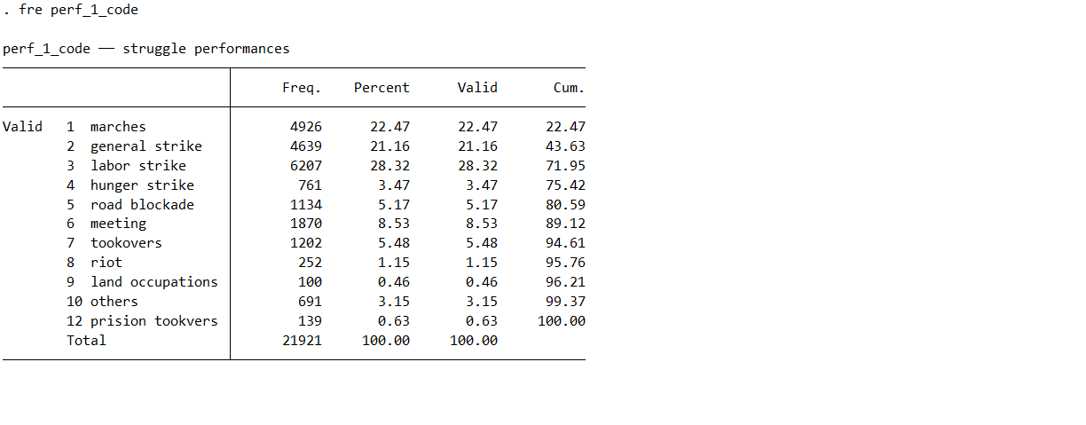

Table 2. Frequencies for struggle performances recoded variable perfor_id, Peruvian protests 1980-2020
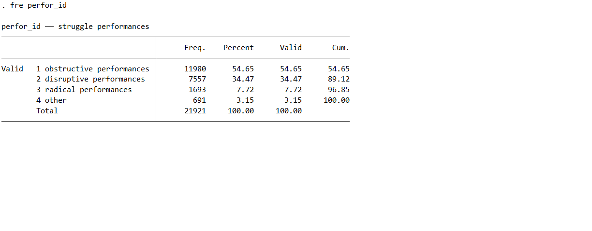
For the construction of the six discrete categories which defines the typology of protest claims (claim_id): labor, environmental, social policy, infrastructure, others and economic policy (Table 4), based on the aggrupation of the original values showed in the Table 3 (dem_id).
Table 3. Frequencies for protests claims original variable dem_id, Peruvian protests 1980-2020
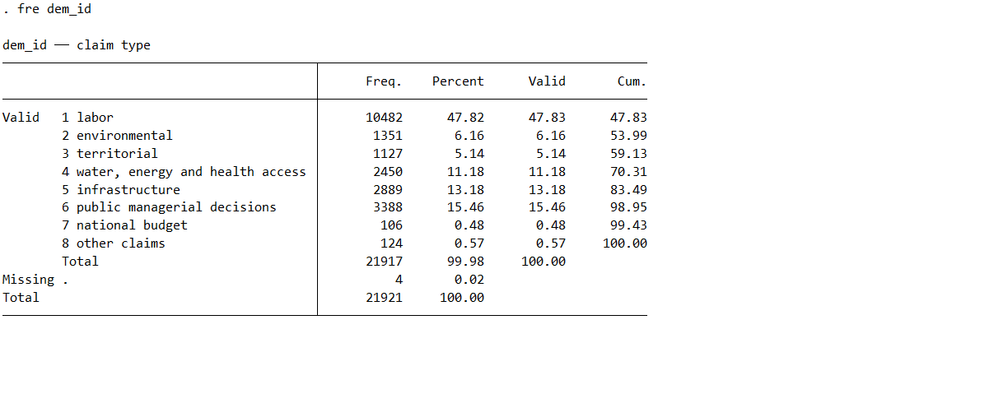

Table 4. Frequencies for protests claims recoded variable claim_id, Peruvian protests 1980-2020
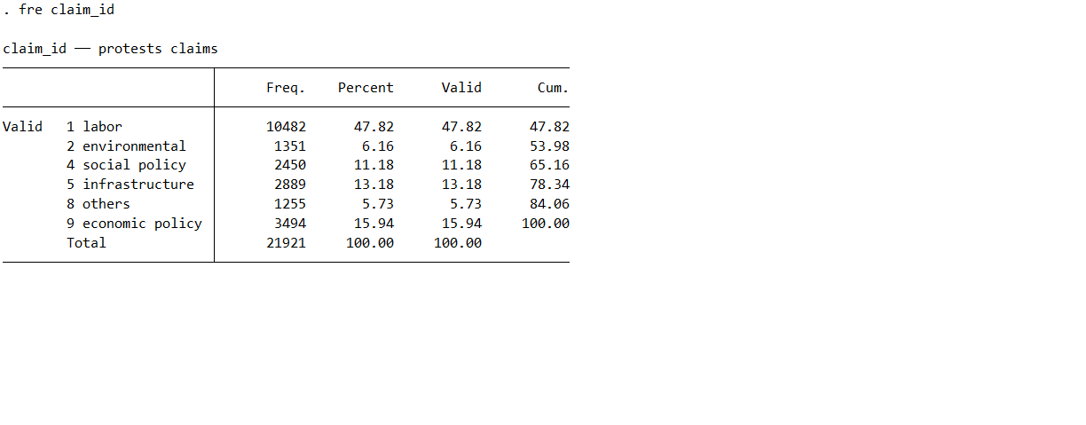
The third variable considered for the control analysis of the crosstabulation of struggle performances by protest claims was protest centralism, defined as the occurrence of the protest event centralized in the capital city of Lima or in the countryside. The .do STATA file attached as an appendix to this paper essay contains the commands applied in the recoding applied to create the discrete variables struggle performances (perf_id) and protest claims (claim_id), and protest centralism (protest_centralism).
Table 5. Frequencies for struggle performances recoded variable perfor_id, Peruvian protests 1980-2020
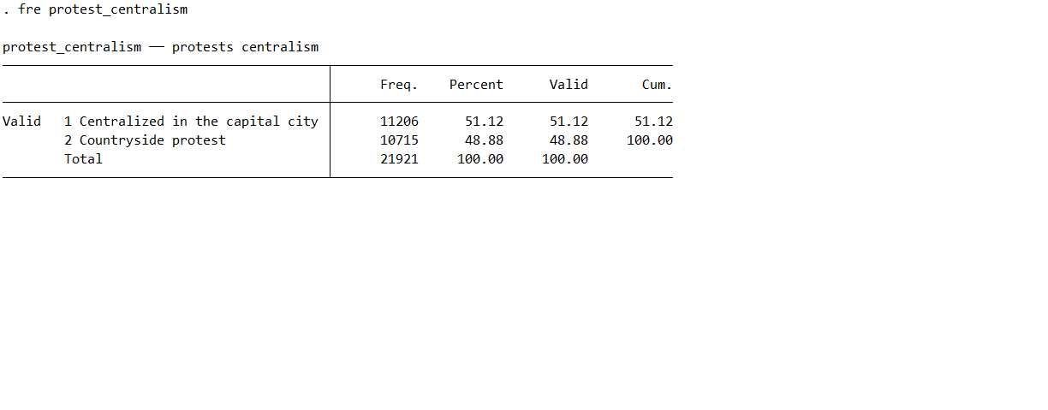

Results
The chi-square test of statistical significance was supportive of the alternative hypothesis of a strong covariation between the protests claims and struggle performances categories and of the rejection of the null hypothesis of non-covariation at a level of significance of 0.001 for 15 degrees of difference. The high magnitude of the value of the chi-square Pearson coefficient in the crosstabulation of struggle performances by protests claims indicates "a greater relative difference” between its observed and expected crosstabulation frequencies (Knoke et al. 2002, 145). Nevertheless, it's necessary to precise that is also an effect of the large size of the sample (Knoke et al. 2002, 147). The chi-square test summarizes the difference across the 24 cells of the Table 3 between the observed and expected frequencies for a degree of difference of 15.
The value of 3.7e+03 calculated by the Stata package chi-square Pearson coefficient test should be read as 3676.19368, as the result of the sum of its 24 components each one calculated by the squared difference between the observed and expected frequencies then divided by the expected frequencies (Table 6), following the formula offered by Knoke et al. (2002, 145).
Indeed, considering this calculation for the interpretation of the chi-square Pearson coefficient showed in Table 6, we can conclude that the 3676.19368 chi square coefficient value (3.7e+03 in Table 3 Stata exported result) is higher than the critical value of 37.697 chi square coefficient value for a degree difference of 15 (Knoke, Bohrnstedt, and Mee 2002, 459–60), considered sufficient to reject the null hypothesis of non-covariation between the discrete variables struggle performances and protests claims in a level of significance of 0.001.
Table 6. Expected and observed frequencies crosstabulation of struggle performances by protests claims, Peruvian protests events 1980-2020
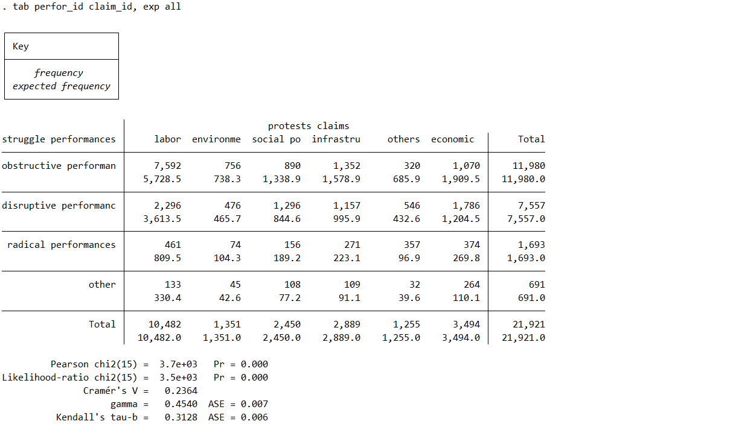
The Table 7 Cramer's V coefficient of 0.2364 also can be interpreted as indicative of a medium effect size of the discrete variable protests claims over the prediction of the covariation of the discrete variable performances of struggles.

Table 7. Crosstabulation percentages of struggle performances by protests claims, Peruvian protests events 1980-2020
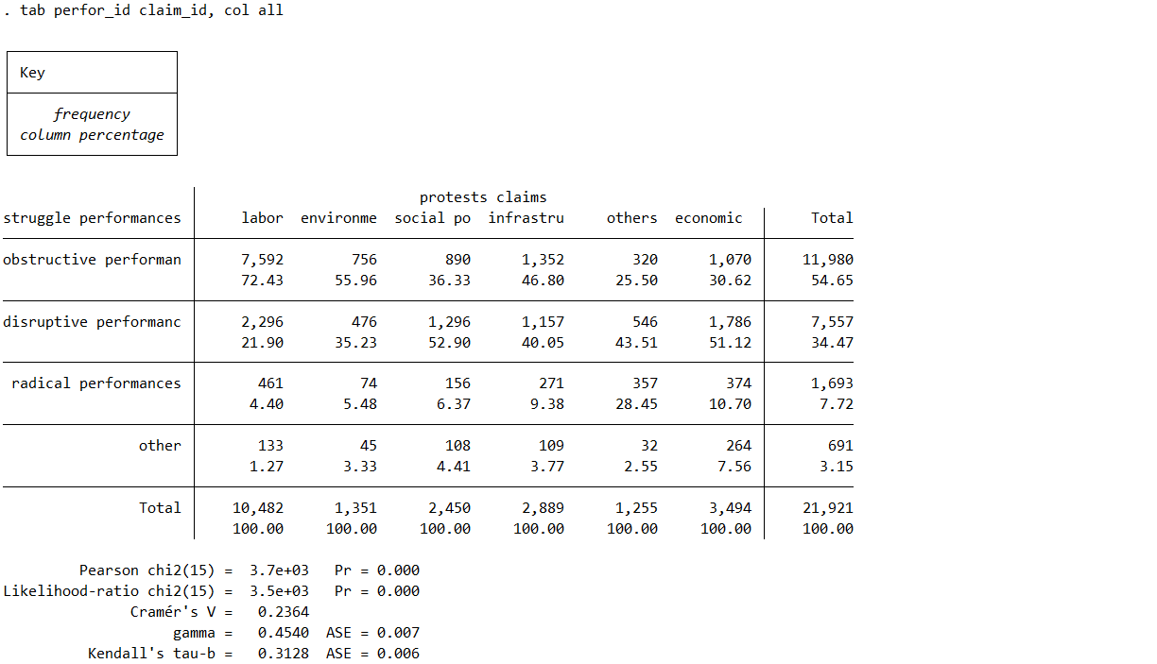
As shown in Table 8 and Table 9, for control analysis, a third variable protest centralism is introduced as a discrete control (measured by the occurrence of the protest in the capital city or in the countryside) in the crosstabulation of struggle performances by protests claims. The comparison of the percentage crosstabulations between the Table 7 and the corresponding ones of Table 8 and Table 9, evidenced the use of certain types of struggle performances depending on the types of protests claims.
The differences in the percentage crosstabulations among the 24 cells of the two subsets of protests separated by the variable protest centralism (Table 8 and Table 9), in comparison with the crosstabulation of the same two variables in the total of protests indifferently of their centralism presented in Table 7. Table 8 crosstabulation of the first subset of 11,206 protests centralized in the capital city of Lima —out of a total of 21,921 protests registered in the Peruvian Protests Database (BPSP) between 1980 and 2020— presented a chi square Pearson coefficient value of 3429.70748 (3.4e+03 in Table 7), calculated with the same method applied for Table 7 crosstabulation offered by Knoke et al. (2002, 145) and is sufficient to reject the null hypothesis of non-covariation of the discrete variable struggle performances by the discrete variable protest claims, considering the conventional critical value of 37.697 for a level of significance of .001.
Table 8. Crosstabulation percentages of struggle performances by protests claims executed at the capital city of Lima, Peruvian protests events 1980-2020
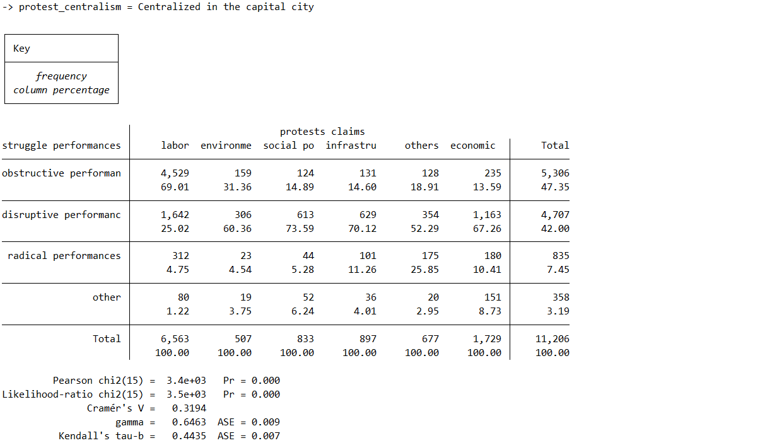

The Cramér’s V coefficient value of 0.31924 reported in Table 8 is higher than the Cramér’s V coefficient value of the crosstabulation of struggle performances by protests claims without the introduction of the third control variable protest centralism reported in Table 7 (0.2364). For the subset of protests centralized in the capital city of Lima, the Cramer’s V coefficient value of 0.31924 reported a stronger effect size for the covariation of struggle performances by protest claims.
Table 9. Crosstabulation percentages of struggle performances by protests claims executed at the countryside, Peruvian protests events 1980-2020
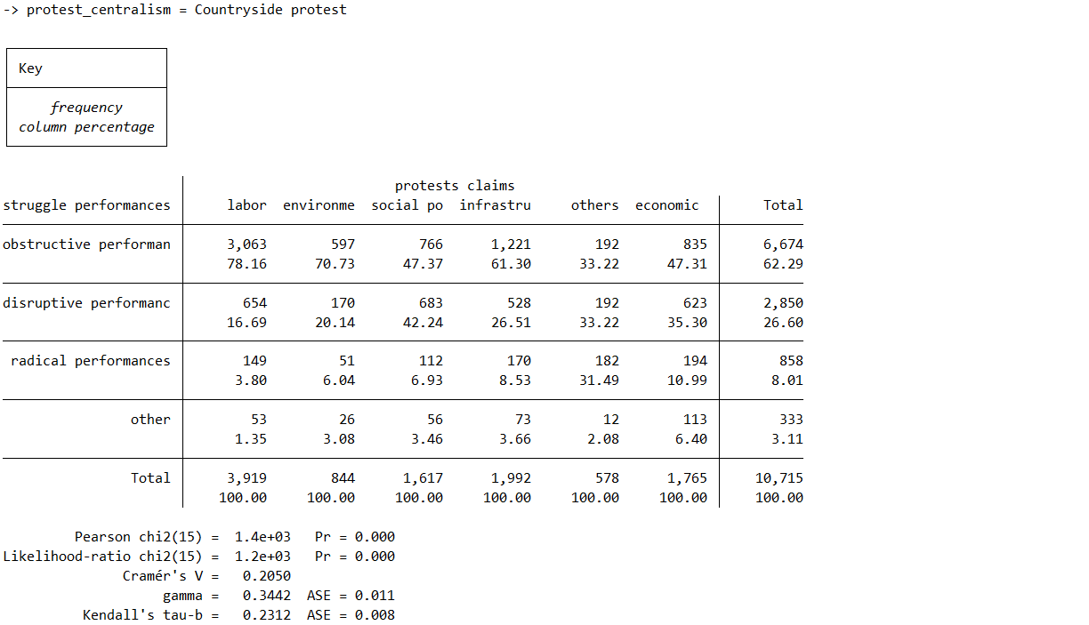

Conclusions
To complete the interpretation of the changes in the crosstabulation percentages of struggle performances by protests claims when protests centralism has been introduced as a control variable, I will state that struggle performances executed in the capital city of Lima to revindicate the same political claims showed differentiated frequencies than the protests executed in the countryside. This segmentation between the repertories of collective action performances disposable for populations and collective challengers of the countryside is differentiated from the repertories of collective action of similar collective actor categories revindicating similar political claims in the capital cities.
For instance, I will emphasize the cell defined by the obstructive performances category percentages of protests revindicating environmental claims showed in Table 7 (55.96%), which is representing a selection of obstructive performances of struggle in the environmental field of contention, as road blockades and general strikes. To subsequently, observe the same cell in the Table 8, which is showing a crosstabulation percentage of 31.36% for the subset of protests centralized in the capital city of Lima, in contrast with the corresponding 70.73% for the subset of countryside protests (Table 9).
Some hypotheses must be built to explain the causal mechanism of the covariation representing the execution of obstructive performances in struggles for environmental claims based on these differences among the crosstabulation percentages between centralized and countryside protests. One could state that the environmental struggles in the countryside imply higher levels of repression and coordination among different challengers to usually contest megaprojects of infrastructure for extractive (agricultural, mining, oil) industries by the dispossession and contamination of land and water.
The road blockades and general strikes are struggle performances with the capacity to obstruct the circulation process of capital reproduction for certain time, and could be selected by countryside challengers participating in the environmental field of contention as effective because of the territorial proximity to the capitalist production of this megaprojects, but also because of the magnitude of the challenge translated in the affectation of the rate of profit of the capitalists investing in the scale of reproduction particular to this megaprojects of extractive industries contested by environmental struggles. The execution of obstructive performances to revindicate environmental claims in the subset of protests centralized in the capital city of Lima is less effective as the road blockades requires the coordinated participation of the truck and mainly bus driver’s organizations to effectively execute them, if not a broader coalition with the labor and student unions to massively march stopping the traffic in the capital city of Lima.
Another cell crosstabulation percentages for which comparison between the two subsets of protests separated by its centralization must be theorized. It’s the cell which represent a segmented subset of protests in which obstructive performances were executed to revindicate infrastructure claims. The Table 7 exhibits a 46.80% crosstabulation percentage representing a subset of protests executed by obstructive performances to revindicate infrastructure claims, but when the same cell is observed in the subset of protests centralized in the capital city of Lima the crosstabulation percentage of this cell reduced to 14.60%.
This observation can be also theorized in line with the assumptions made to built an hypothesis to explain the differences in the covariation among obstructive performances and environmental claims, while infrastructure claims are usually related to social reproduction necessities experienced as grievances by larger populations sectors usually territorially organized, and because protests executed for the revindication of infrastructure claims mainly target the state agencies as the Ministry of Transportation or Economy, by other struggle performances which are not effective because of the affectation of the capital circulation but to pull for a political decision which satisfy their particular infrastructure claims as the construction of a promised road, university or productive project.

Cited references
Arce, Moisés. 2014a. “Base de Protestas Sociales Del Perú Dataset.” University of Missouri.
———. 2014b. Resource Extraction and Protest in Peru. Pittsburgh: University of Pittsburgh Press.
Knoke, David, George W. Bohrnstedt, and Alisa Potter Mee. 2002. Statistics for Social Data Analysis. 4th ed. Itasca, Ill: F.E. Peacock Publishers.
Koopmans, Ruud, and Dieter Rucht. 2002. “Protest Event Analysis.” In Methods of Social Movement Research, edited by Bert Klandermans and Suzanne Staggenborg, 231–59. London: University of Minnesota Press.
McAdam, Doug, Sidney Tarrow, and Charles Tilly. 2001. Dynamics of Contention. Cambridge: Cambridge University Press.
Tilly, Charles. 2002. “Event Catalogs as Theories.” Sociological Theory 20: 248–54. https://doi.org/10.1111/1467-9558.00161.
Tilly, Charles, and Sidney Tarrow. 2015. Contentious Politics. London: Paradigm Publishers.
Wada, Takeshi. 2004. “Event Analysis of Claim Making in Mexico: How Are Social Protest Transformed into Political Protest?” Mobilization: An International Journal 9 (3): 241–57.

Appendix: STATA .do file

